MySQL Exercise 2

1.Select from any table a number and determine whether it is within a given range (for example, between 1 and 10).

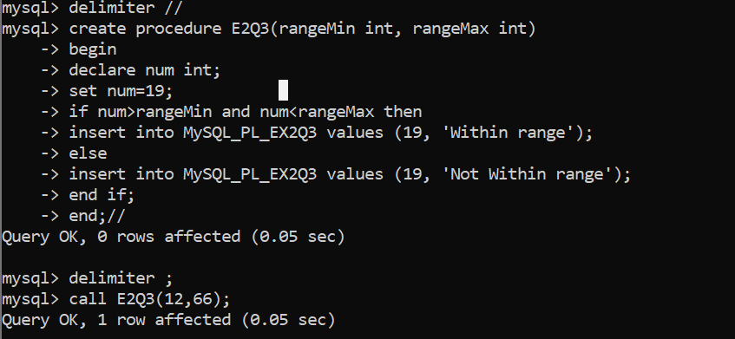

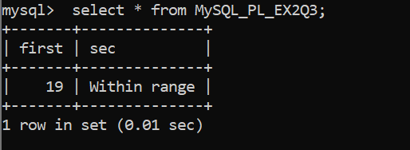

2. Select from any table three positive integers representing the sides of a triangle, and determine whether they form a valid triangle. Hint: In a triangle, the sum of any two sides must always be greater than the third side.

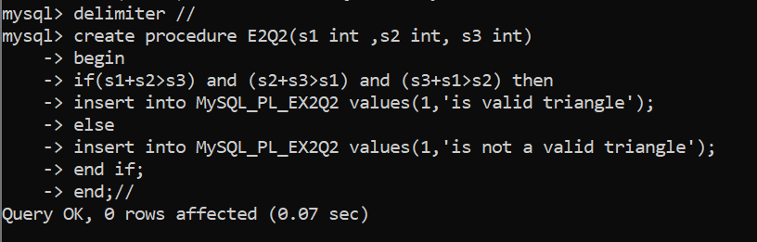

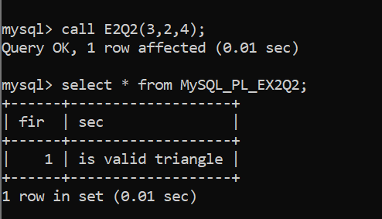

3. Check if a given a year is a leap year. The condition is:- year should be (divisible by 4 and not divisible by 100) or (divisible by 4 and divisible by 400.). The year should be Selected from some table.

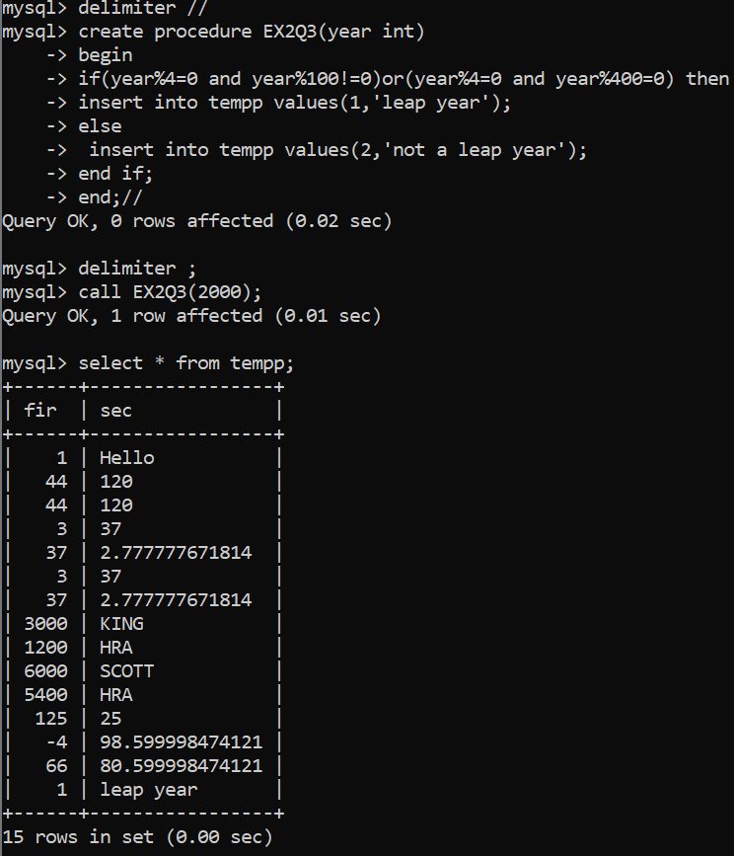

4. Write a program that Selects from any table two character strings. Your program should then determine if one character string exists inside another character string.

mysql> create table string(

-> string1 varchar(20),

-> string2 varchar(20));

mysql> insert into string(

-> string1 ,

-> string2)

-> values(

-> 'abc', 'abcde');

[4:13 pm, 19/10/2024] Parthavi(CDAC): mysql> delimiter //

mysql> create procedure matcher()

-> begin

-> DECLARE str1 VARCHAR(255);

-> DECLARE str2 VARCHAR(255);

-> SELECT string1, string2 INTO str1, str2 FROM string WHERE string1 = 'abc' LIMIT 1;

-> IF str2 LIKE '%abc%' THEN

-> INSERT INTO temp VALUES(1, 'exist');

-> ELSE

-> INSERT INTO temp VALUES(1, 'not exist');

-> END IF;

-> end;

-> //

Query OK, 0 rows affected (0.02 sec)

mysql> delimiter ;

mysql> call matcher();

Query OK, 1 row affected (0.02 sec)

mysql> select \* from temp;

+------+---------------------+

| fir | rec |

+------+---------------------+

| 1 | exist |

+------+---------------------+